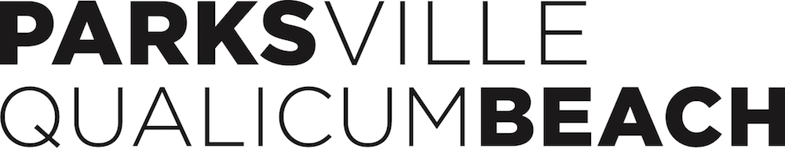

PQBTA Events Kit Loan Contract

Organization
Contact Person
Event Name
Event Location
Event Dates
Pick Up Date & Time
Return Date & Time
Contact email & # at Event
Event Kit Loan Program Rental Terms and Conditions |  | Initial
The Event Kit Loan Program is in place to assist public and community events hosted in Parksville Qualicum Beach typically by not-for-profit groups and associations; these groups will receive priority on bookings.
All Event Kit items remain the property of the PQBTA and must be picked up and returned to the PQBTA office between the following hours: Monday to Friday from 9:00
a.m. – 3:00 p.m. excluding statutory holidays - absolutely no exceptions
Reservations are to be made 7 days in advance by returning this completed form to the PQBTA office with the damage deposit and rental fee. The Event Kit is available for your event to a maximum of 7 days. A $50.00 per day late charge will be applied if equipment is not returned on the date previously agreed to. After 7 days, your credit card will be charged for unreturned equipment at the cost of each piece you have borrowed
A $500 damage deposit must be taken by Credit Card at the time of the reservation confirmation. This charge will be refunded to your card upon return of the Event Kit and deemed in the same condition & accounted for in good repair as when rented.
A $25 includes GST administration fee must be paid by credit card at the time of confirmation.
GST Registration # 13712 6546 RT0001
All Event Kit items must be returned in the same condition and packaging as received (excepting normal wear and tear), including all instruction and reference manuals (please follow tent set up/strike procedures provided on pick up). The borrower shall be held responsible for cleaning all items before returning. Cleaning charges will apply if the equipment is not properly cleaned prior to return. Garbage bags must be used to line garbage and recycle cans.
The borrower shall be held responsible for the cost of repairs or replacement to damaged, lost, or stolen equipment. Should you notice any damage to a piece of equipment, you must call the PQBTA office (250) 248-6300 ext. 5 prior to the start time of your event and leave a message noting the damage. If you do not, you will assume responsibility for equipment that is returned damaged or in unclean condition.
Cleaning charges and replacement costs will be at current market value and deducted from the damage deposit immediately.

As an authorized signatory of the above listed organization, I acknowledge that I have read and understood the Terms and Conditions as outlined above and accept sole responsibility for the Event Kit used at our event. I acknowledge that the equipment will not be released until the $500 deposit and the $25 admin fee have been received. I understand that the deposit submitted will be cashed if any of the equipment I borrow is lost or damaged, in any way during my rental, or not cleaned before being returned.

Renter
Signature
Title
Organization

PQBTA Use
Rental Fee received
Damage Deposit received

Please complete this document in its entirety and submit with the deposit and admin fee to:
Parksville Qualicum Beach Tourism #107-425 Stanford Avenue East, Parksville BC V9P 2N4
Contact: Blain Sepos, 250-248-6300 ext 5 or blain@pqbtourism.com

